Excel Assignment - 7

- Using Insert Function, give examples of any function available in the different dropdowns present in the function library. For example AutoSum, Recently Used, Text, Date & Time, etc.
Answer: I have used Date and time function under Formulas tab.
Firstly, I clicked on Insert Function and choose Day function in drop down list and selected the cell A2 and press ok and it gives the result of day of the given date. Same way , I was able to find the month and year of given date in separated columns.
Please check the following screenshot

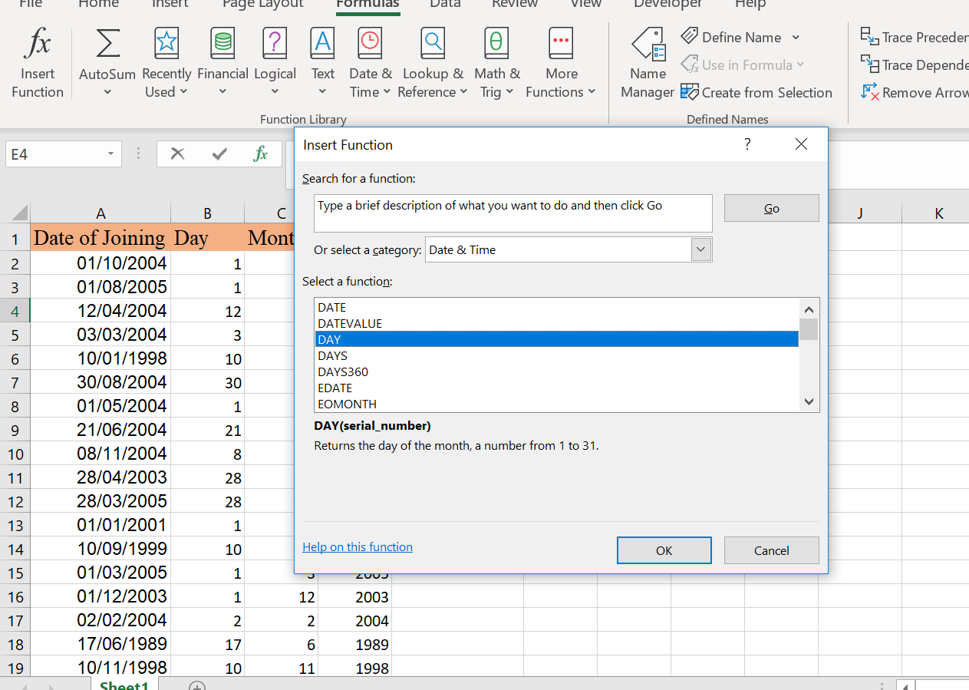

2. What are the different ways you can select columns and rows?

Answer: To select the columns, click on top edge of column header or column in the table which will select the entire column. Another shortcut is to press Ctrl + Spacebar or Ctrl +Shift+Down Arrow after selecting the cell in column we want to select.
To select the rows, click on left border of the table row which will select the entire row. Another Shortcut is Ctrl +Shift+ Right Arrow after selecting the cell in row we want to select.

3. What is AutoFit and why do we use it?

Answer: Autofit is a feature which resizes the width of column and hight of row automatically to fit the data. It helps in holding the largest values in cell without changing the width of column and height of row.

4. How can you insert new rows and columns into the existing table?

Answer: To insert the row, click the cell and Go to Insert and click on Rows. It would insert the row above the selected cell. We can do the same with by right clicking the cell and selecting insert option from list.
To insert the Column, click the cell and Go to Insert and click on Columns. It would insert the column left of selected cell. We can do the same with by right clicking the cell and selecting insert option from list.

5. How do you hide and unhide columns in excel?

Answer: Select the columns you want to hide.
Go to the Fomat in cells group under home tab.
Under Visibility, Click on Hide & Unhide and click on Hide columns

6. Create an appropriate table within the worksheet and use different functions available in the AutoSum command.

Answer: I have used different function within AutoSum and created following table.
I have attached the screenshot of worksheet of my task.
Autosum has dropdown list which has number of functions for eg: Sum, Average, Count, Max and Min.

